//Programmer: Kerwin Garcia

//The purpose of this program is to convert

//inputted seconds into hours, minutes, and seconds

int isecs, hours, min, secs;

private void button1_Click(object sender, EventArgs e)

{

isecs = int.Parse(textBox1.Text);

if (isecs < 60)

{

MessageBox.Show(isecs + " Seconds");

}

else if (isecs < 3600)

{

min = (isecs / 60);

secs = (isecs % 60);

MessageBox.Show(min + " Minutes" + " and " + secs + " Seconds");

}

else if (isecs < 86401)

{

hours = (isecs / 3600);

min = (isecs % 3600) / 60;

secs = (isecs % 3600) % 60;

MessageBox.Show(hours + " Hours " + min + " Minutes" + " and " + secs + " Seconds");

}

}

private void textBox1_Validating(object sender, CancelEventArgs e)

{

if (isecs > 86400)

{

MessageBox.Show("Seconds can not be greater than 86400!");

e.Cancel=true;

}

}

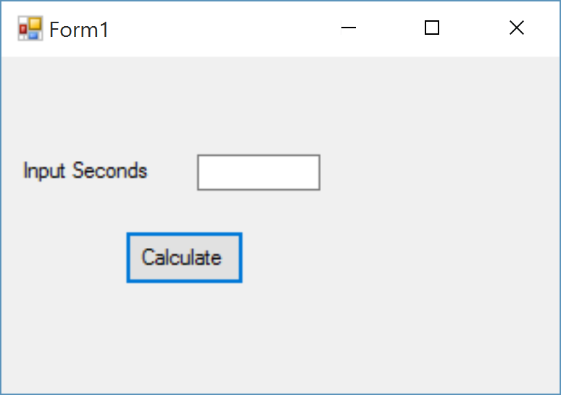

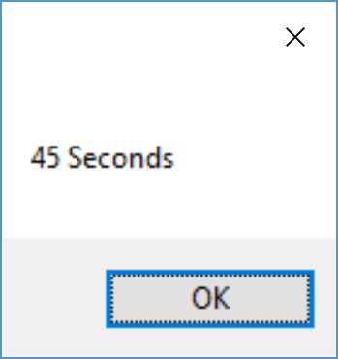

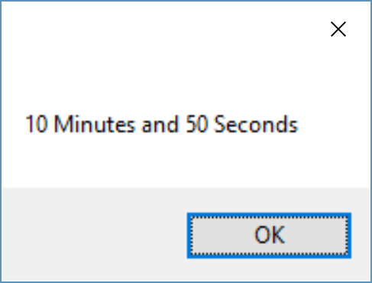

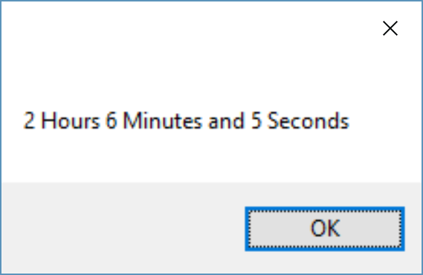

//Programmer:Kerwin Garcia

//ISYS 350

//The purpose of this program is to compute

//electricty cost by inputting Kilowatt-Hours used

private void button1_Click(object sender, EventArgs e)

{

double kwh,cost;

double rate;

double low rate;

kwh = double.Parse(textBox1.Text);

if (kwh > 2000)

{

rate = (kwh * .25);

textBox2.Text = lowrate.ToString("c");

}

else if (kwh <= 100)

{

rate = ((kwh - 100) * .35 + 20);

textBox2.Text = rate.ToString("c");

}

else if (kwh <= 400)

{

rate = ((kwh - 100) * .45 + 50);

textBox2.Text = rate.ToString("c");

}

else if (kwh > 400)

{

rate = ((kwh - 400) * .60 + 140);

textBox2.Text = rate.ToString("c");

}